DSA0410 – Fundamentals of Data Science

Day - 4

Name : Mithlesh N
Reg.no.: 192424364

16. Scenario: You are working on a project that involves analyzing customer reviews for a product. You have a dataset containing customer reviews, and your task is to develop a Python program that calculates the frequency distribution of words in the reviews.
Question: Develop a Python program to calculate the frequency distribution of words in the customer reviews dataset?

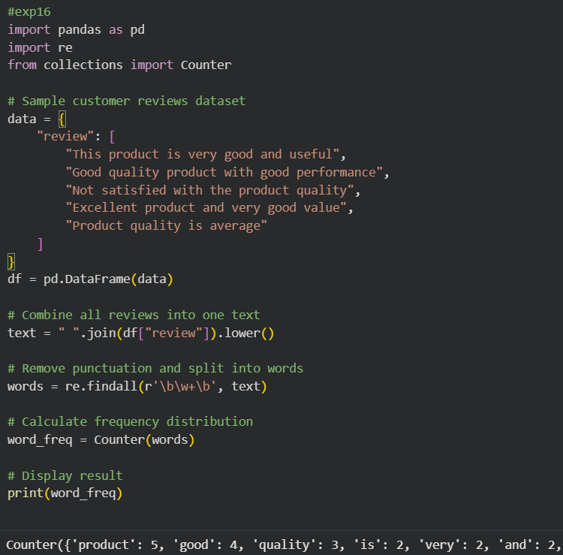

17. Scenario: You are a data analyst working for a marketing research company. Your team has collected a large dataset containing customer feedback from various social media platforms. The dataset consists of thousands of text entries, and your task is to develop a Python program to analyze the frequency distribution of words in this dataset. Your program should be able to perform the following tasks:
• Load the dataset from a CSV file (data.csv) containing a single column named "feedback" with each row representing a customer comment.
• Preprocess the text data by removing punctuation, converting all text to lowercase, and eliminating any stop words (common words like "the," "and," "is," etc. that don't carry significant meaning).
• Calculate the frequency distribution of words in the preprocessed dataset.
• Display the top N most frequent words and their corresponding frequencies, where N is provided as user input.
• Plot a bar graph to visualize the top N most frequent words and their frequencies.
Question: Create a Python program that fulfills these requirements and helps your team gain insights from the customer feedback data.

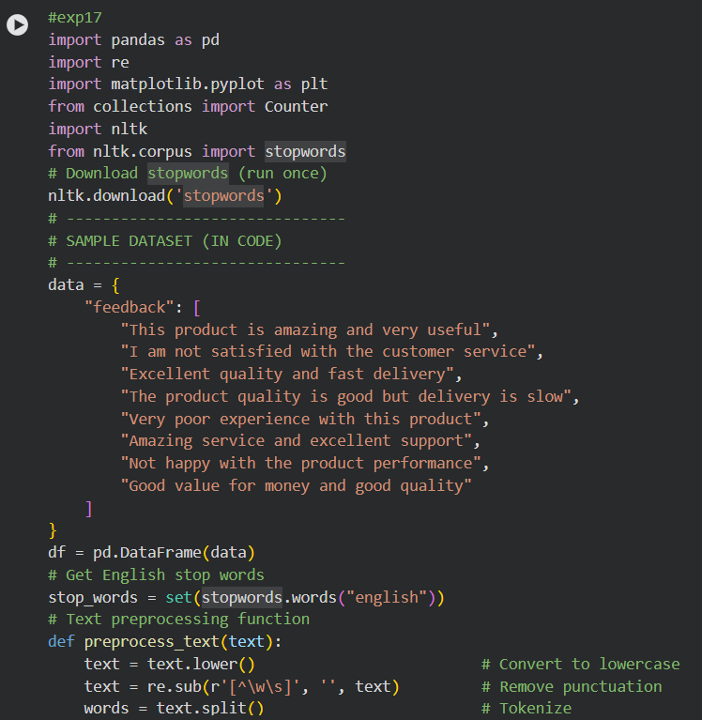
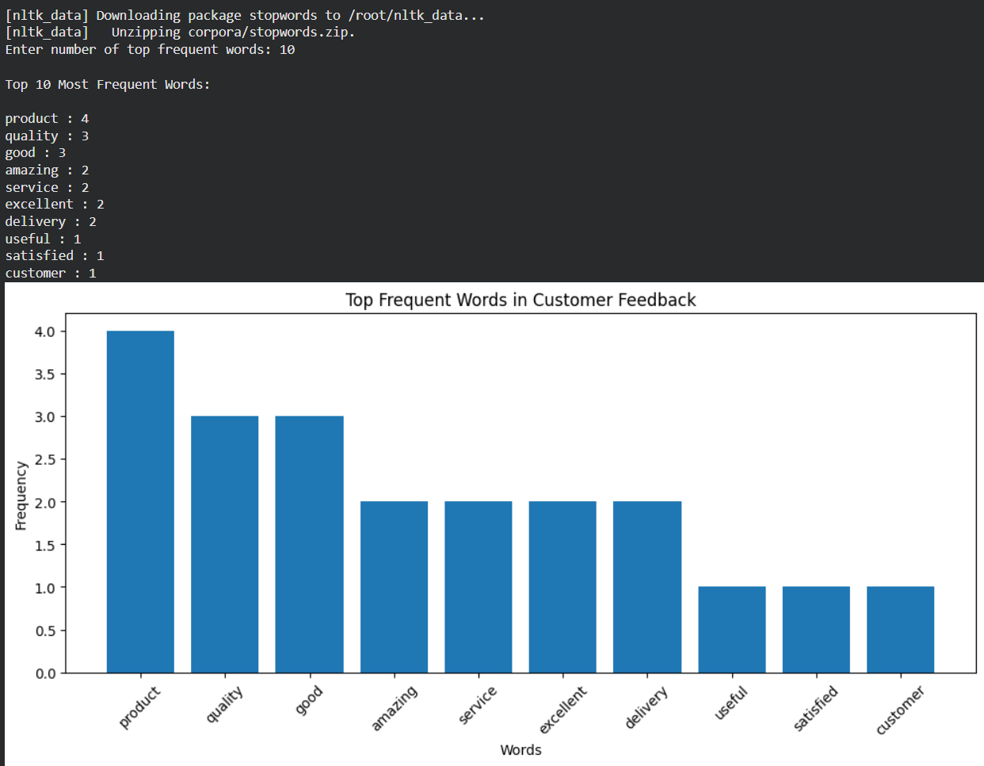

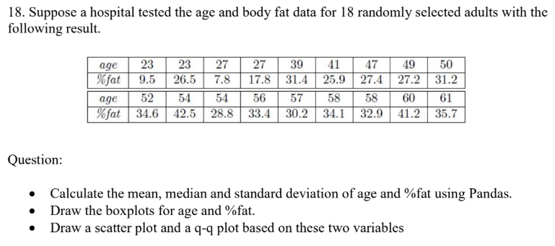

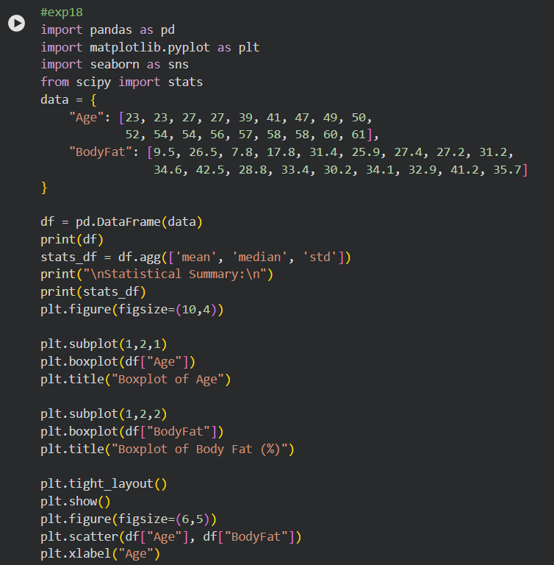

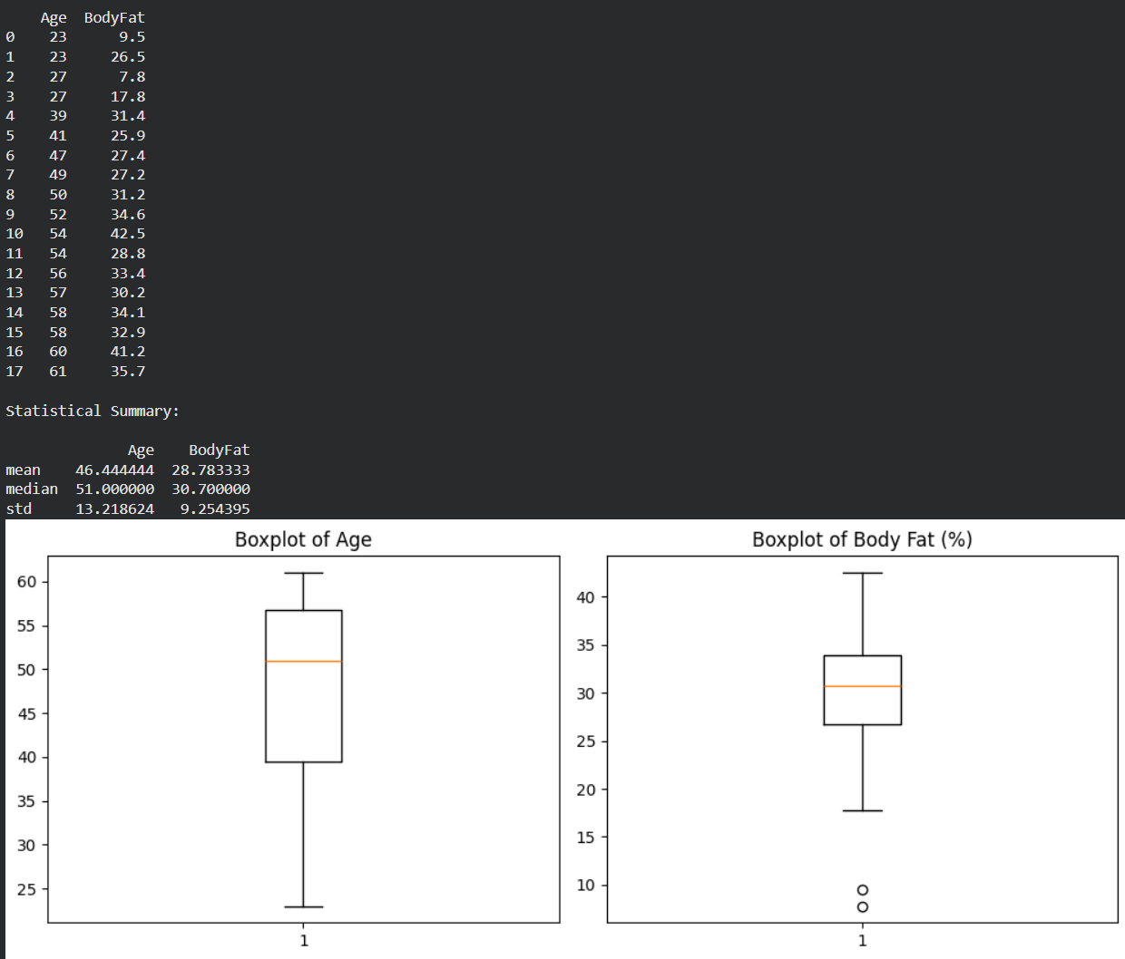
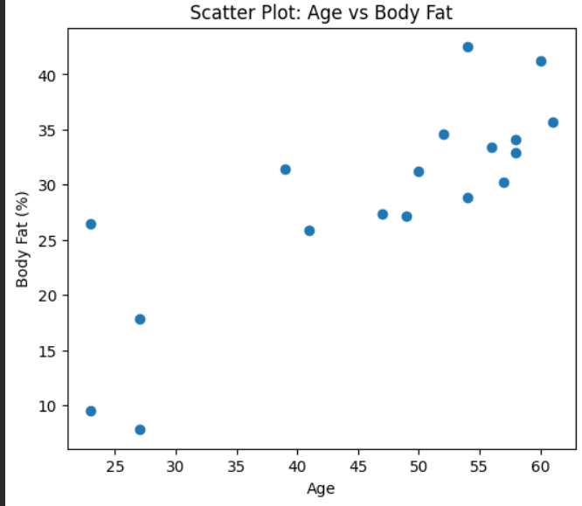
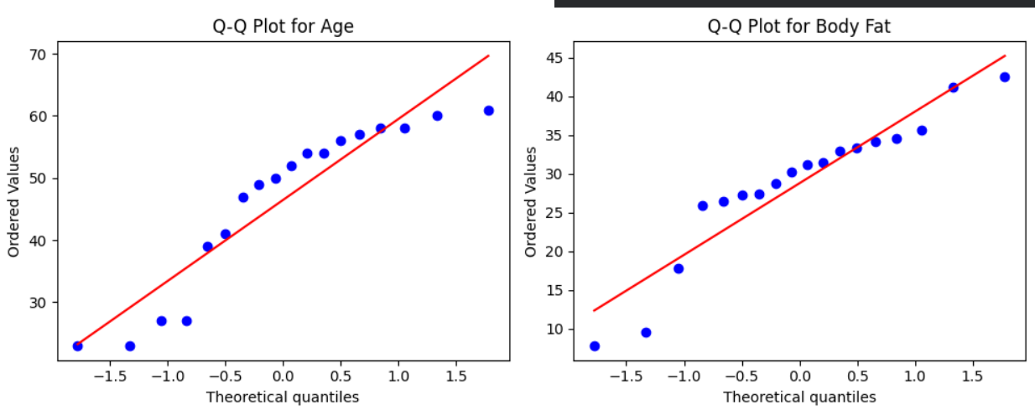

19. Scenario: You are a medical researcher investigating the effectiveness of a new drug in reducing blood pressure. You conduct a clinical trial with a sample of 50 patients who were randomly assigned to receive either the new drug or a placebo. After measuring their blood pressure levels at the end of the trial, you obtain the data for both groups. Now, you want to determine the confidence intervals for the mean reduction in blood pressure for both the drug and placebo groups.
Question: "What is the 95% confidence interval for the mean reduction in blood pressure for patients who received the new drug? Also, what is the 95% confidence interval for the mean reduction in blood pressure for patients who received the placebo?

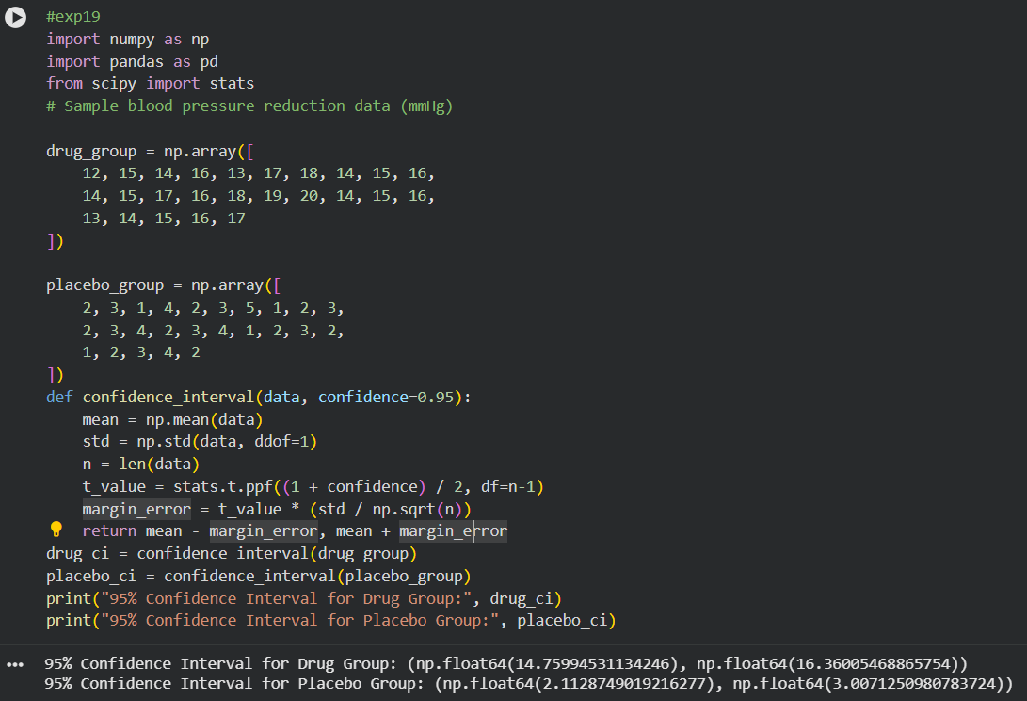
20. Scenario: You are a data scientist working for an e-commerce company. The marketing team has conducted an A/B test to evaluate the effectiveness of two different website designs (A and B) in terms of conversion rate. They randomly divided the website visitors into two groups, with one group experiencing design A and the other experiencing design B. After a week of data collection, you now have the conversion rate data for both groups. You want to determine whether there is a statistically significant difference in the mean conversion rates between the two website designs.
Question: "Based on the data collected from the A/B test, is there a statistically significant difference in the mean conversion rates between website design A and website design B?"

